**Inventory Management System**

A Mini project report submitted for the partial fulfillment of

academic requirements of

**MASTER OF COMPUTER APPLICATIONS**

Submitted by

**STUDENT NAME: Gayatri Baragi**

**USN: 4NI22MC032**

**STUDENT NAME: Anusha R**

**USN: 4NI22MC008**



**Department of Master of Computer Applications**

**National Institute of Engineering**

(An Autonomous Institute under Visvesvaraya Technological University, Belagavi)

Manandavadi Road, Mysuru – 570 008, Karnataka, INDIA

**2022-2023**

**The National Institute of Engineering**

(An Autonomous Institute under Visvesvaraya Technological University, Belagavi)

Manandavadi Road, Mysuru – 570 008, Karnataka, INDIA

* Accredited by National Board of Accreditation,
* New Delhi Recognized by AICTE,
* New Delhi Grant-in-Aid by Government of Karnataka

**Department of Master of Computer Applications**

**CERTIFICATE**

Certified that the Mini project work entitled **‘Inventory Management System’** carried out by **Gayatri** **Baragi, USN: 4NI22MC032** and **Anusha** **R**, **USN**: **4NI22MC008** the bonafide students at The National Institute of Engineering is submitted in partial fulfillment of academic requirements in Master of Computer Applications, **The National Institute of Engineering, Mysuru,** an autonomous institute under Visvesvaraya Technological University, Belagavi during the year 2022-2023. The project report has been approved as it satisfies the academic requirements in respect of Mini Project work.

Name & Signature of Guide1 Name & Signature of Guide2 Name & Signature of the Hod

|  |
| --- |
| **Ms. Ms. Sandhya N Ms**. **Bhavani** **R Dr. Sanjay Kumar C K** |
| **As Assistant** **Professor Assistant** **Professor** **Assistant Professor & HoD**  Dept. of MCA, NIE Dept. of MCA, NIE Dept. of MCA, NIE |
|  |

# DECLARATION

We **Gayatri Barag**ibearing USN: **4NI22MC032 and Anusha R** USN: **4NI22MC008** student at **The National Institute of Engineering**, Department of Master of Computer Application, The National Institute of Engineering, Mysuru hereby declare that the mini project work entitled **“Inventory Management System”** has been carried out by us**.** This mini project work is submitted to **The National Institute of Engineering**, Mysuru, (An Autonomous institute under VTU, Belagavi) in partial fulfillment of the course requirements in Master of Computer Applications during the academic year 2022-2023. This written submission represents a record of original work and I have adequately cited and referenced the original sources.

Place: Mysuru

Date: (Signature of the student)

**Introduction**

Inventory is the stock of physical items such as materials, components, work in progress, finished goods etc. held at a specific location at a specific time. Inventory is the merchandise that is purchased and or produced and stored for eventual sale. Inventory is a list of what you have in company accounts. Inventory usually refers to the value of stocks as distinct from fixed assets. An inventory would include items which are held for sale in the ordinary course of business or which are in the process of production for the purpose of sale or which are to be used in the production of goods or service which will be for sale.

The main objective of inventory management is to maintain inventory at appropriate level to avoid excessive or shortage of inventory because both the cases are undesirable for business. Thus, management is faced with the following confiding objectives: To keep inventory at sufficiently high level to perform production and Sales activities smoothly. To minimize investment in inventory at minimum level to maximize Profitability. The purpose of this document is to present a detailed description of the inventory management system. It will explain the purpose and the features of the software, what the software will do, the constraints under which it must operates and how the software will react to the external stimuli.

**Literature Survey:**

* **“Principles of Inventory Management” by Max Muller and Tom F. Wallace:**

This book is considered a foundational resource for inventory management. It covers a wide range of topics, from basic concepts to advanced techniques, making it suitable for both beginners and experts.

* **“Inventory Management: Principles, Concepts, and Techniques” by F. Robert Jacobs and Richard B. Chase:**

This text offers a comprehensive overview of inventory management principles and practices. It includes discussion on various inventory models and their application.

* **“The EOQ Inventory Formula” by Stefan Scholtes:**

Focusing on the Economic Order Quantity (EOQ) model, this book delves deep into the mathematical aspects of inventory management. It’s a valuable resource for those interested in quantitative inventory analysis.

* **“Inventory Management and Production Planning and Scheduling” by Edward A. Silver, David F. Pyke, and Rein Peterson:**

This book connects inventory management with production planning and scheduling, emphasizing the importance of integrating these functions for efficient operations.

* **“The New Economics for Industry, Government, Education” by W. Edwards Deming:**

Although not exclusively about inventory management, Deming’s work on quality management and continuous improvement has had a profound impact on inventory control and overall supply chain management.

**Existing System:**

Current system is a Legacy one in which users are maintaining records explicitly, to store the information like supplier’s details, product details, category and, customer details as well as employee details. It is very difficult to maintain historical data. Also, regular investments need to purchase stationary every year.

* It is difficult to maintain important information
* More manual hours need to generate required reports
* It does not show any sales track and helps the sales profit
* Does not have the ability to manage all the details in a single application

**Proposed system:**

Proposed system is a software application which avoids more manual hours that need to spend in record keeping and generating reports.

Advantages:

The following are the advantages of proposed system

• Easy to manage all the daily transactions

• Can generate required reports easily

• Centralized database helps in avoiding conflicts

• Easy to use GUI that does not requires specific training

**System architecture:**

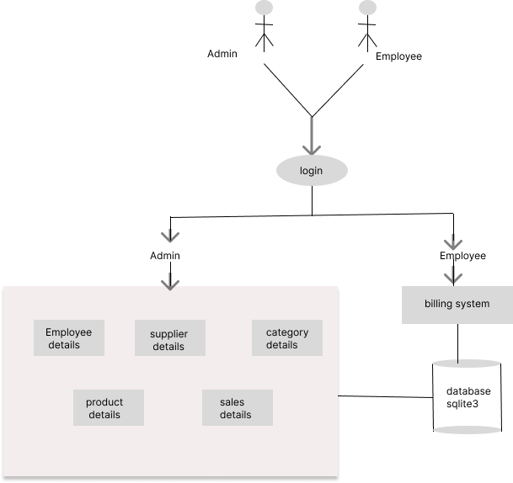

**Workflow design:**

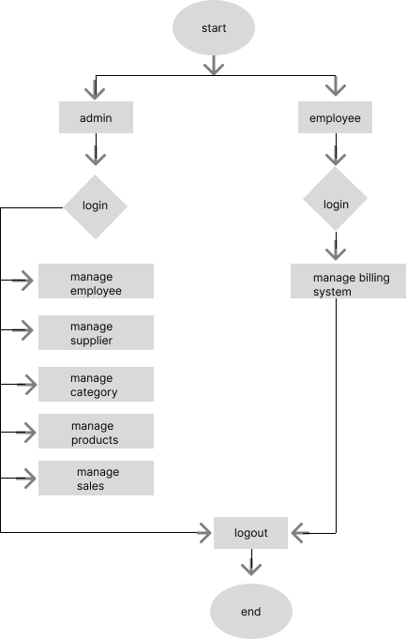

**Usecase Design:**

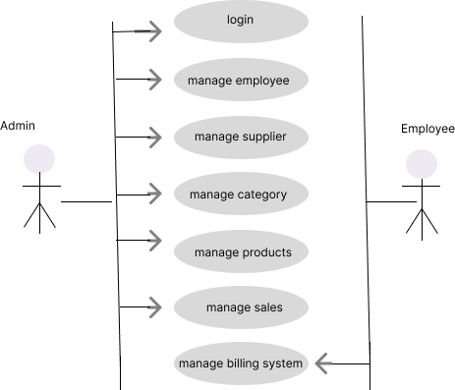

## **System Requirements Specifications:**

**Hardware Requirements:**

* Processors: Intel core i3 processor or above.
* Disk space: 1GB or more
* Operating System: Windows 7 or later
* Python versions: 2.7.X ,3.6.X

**Software requirements:**

* Editor: PyCharm
* Database: sqlite3
* Frontend: Python

**Functional Requirements:**

The system must have a password protected access system such that only people with authenticated credential.

The system maintains the seller details and the type of product purchased and generates unique id for them.

The system takes the sales report and generates sales visualization for better understanding.

**Non-Functional Requirements:**

**Usability:**

* The system must be easy to access by all the users.
* The system must be intuitive and simple in the way it displays all relevant data and relationships.

**Reliability:**

* The system must provide a password enabled login to the user to avoid any foreign entity changing the data in the system.
* The system should not update the data in any database for any failed processes.

**Performance:**

* The system must not lag, because the workers using it don’t have down-time to wait for it to complete an action.
* The system must complete updating the databases, adding of recipe, ingredient, vendor and occasions successfully every time the user requests such a process.

**CODE**

import sqlite3

from tkinter import *

from PIL import ImageTk,Image

from employee import employeeClass

from supplier import supplierClass

from category import categoryClass

from product import productClass

from sales import salesClass

from billing import billClass

from tkinter import ttk,messagebox

import sqlite3

import os

import time

class IMS:

def __init__(self, root):

self.root = root

self.root.geometry("1350x700+0+0")

self.root.title("Inventory Management System")

self.root.config(bg="white")

# ===title===

title = Label(self.root, text="Inventory Management System",font=("times new roman", 40, "bold"), bg="#010c48",fg="white", anchor="w", padx=20).place(x=0, y=0, relwidth=1, height=70)

btn_logout = Button(self.root, text="Logout", command=self.logout,font=("times new roman", 15, "bold"), bg="yellow",cursor="hand2").place(x=1150, y=10, height=47, width=170)

self.lbl_clock = Label(self.root,text="Welcome to Inventory Management System\t\t Date: DD-MM-YYYY\t\t Time: HH-MM-SS",font=("times new roman", 15), bg="#4d636d", fg="white")

self.lbl_clock.place(x=0, y=70, relwidth=1, height=30)

# ===left_menu===

self.MenuLogo = Image.open(r"C:\Users\gayat\OneDrive\Desktop\pythonprojinvent\images\invent.jpg")

self.MenuLogo = self.MenuLogo.resize((200, 200))

self.MenuLogo = ImageTk.PhotoImage(self.MenuLogo)

LeftMenu=Frame(self.root, bd=2, relief=RIDGE, bg="white")

LeftMenu.place(x=0, y=102, width=200, height=533)

lbl_MenuLogo=Label(LeftMenu, image=self.MenuLogo)

lbl_MenuLogo.pack(side=TOP, fill=X)

btn_employee = Button(LeftMenu, text="Employee",command=self.employee, font=("times new roman", 20, "bold"), bg="white", bd=3,cursor="hand2").pack(side=TOP, fill=X)

btn_supplier = Button(LeftMenu, text="supplier",command=self.supplier, font=("times new roman", 20, "bold"), bg="white", bd=3,cursor="hand2").pack(side=TOP, fill=X)

btn_Category = Button(LeftMenu, text="Category",command=self.category, font=("times new roman", 20, "bold"), bg="white", bd=3,cursor="hand2").pack(side=TOP, fill=X)

btn_product = Button(LeftMenu, text="product",command=self.product, font=("times new roman", 20, "bold"), bg="white", bd=3,cursor="hand2").pack(side=TOP, fill=X)

btn_billing = Button(LeftMenu, text="Billing",command=self.billing, font=("times new roman", 20, "bold"), bg="white", bd=3,cursor="hand2").pack(side=TOP, fill=X)

btn_sales = Button(LeftMenu, text="sales", command=self.sales,font=("times new roman", 20, "bold"), bg="white", bd=3,cursor="hand2").pack(side=TOP, fill=X)

self.lbl_employee = Label(self.root, text="Total Employee\n[0]", bd=5, relief=RIDGE, bg="#33bbf9", fg="white",

font=("goudy old style", 20, "bold"))

self.lbl_employee.place(x=300, y=120, height=150, width=300)

self.lbl_supplier = Label(self.root, text="Total supplier\n[0]", bd=5, relief=RIDGE, bg="#33bbf9", fg="white",

font=("goudy old style", 20, "bold"))

self.lbl_supplier.place(x=650, y=120, height=150, width=300)

self.lbl_Category = Label(self.root, text="Total Category\n[0]", bd=5, relief=RIDGE, bg="#33bbf9", fg="white",

font=("goudy old style", 20, "bold"))

self.lbl_Category.place(x=1000, y=120, height=150, width=300)

self.lbl_product = Label(self.root, text="Total product\n[0]", bd=5, relief=RIDGE, bg="#33bbf9", fg="white",

font=("goudy old style", 20, "bold"))

self.lbl_product.place(x=300, y=300, height=150, width=300)

self.lbl_sales = Label(self.root, text="Total sales\n[0]", bd=5, relief=RIDGE, bg="#33bbf9", fg="white",

font=("goudy old style", 20, "bold"))

self.lbl_sales.place(x=650, y=300, height=150, width=300)

# ===Footer===

lbl_footer = Label(self.root,text="Inventory Management System \nif any queries contact 953*****89 or ga****@gmail.com",font=("times new roman", 12), bg="#4d636d", fg="white").pack(side=BOTTOM, fill=X)

self.update_content()

# =======================================================================

def employee(self):

self.new_win=Toplevel(self.root)

self.new_obj=employeeClass(self.new_win)

def supplier(self):

self.new_win=Toplevel(self.root)

self.new_obj=supplierClass(self.new_win)

def category(self):

self.new_win=Toplevel(self.root)

self.new_obj=categoryClass(self.new_win)

def product(self):

self.new_win=Toplevel(self.root)

self.new_obj=productClass(self.new_win)

def billing(self):

self.new_win = Toplevel(self.root)

self.new_obj = billClass(self.new_win)

def sales(self):

self.new_win=Toplevel(self.root)

self.new_obj=salesClass(self.new_win)

def update_content(self):

con=sqlite3.connect(database=r'ims.db')

cur=con.cursor()

try:

cur.execute("Select * from product")

product=cur.fetchall()

self.lbl_product.config(text=f"Total products\n[{str(len(product))}]")

cur.execute("Select * from supplier")

supplier = cur.fetchall()

self.lbl_supplier.config(text=f"Total suppliers\n[{str(len(supplier))}]")

cur.execute("Select * from category")

category = cur.fetchall()

self.lbl_Category.config(text=f"Total categories\n[{str(len(category))}]")

cur.execute("Select * from employee")

employee = cur.fetchall()

self.lbl_employee.config(text=f"Total employees\n[{str(len(employee))}]")

bill=len(os.listdir('bill'))

self.lbl_sales.config(text=f"total sales[{str((bill))}]")

time_ = time.strftime("%I:%M:%S")

date_ = time.strftime("%d-%m-%Y")

self.lbl_clock.config(text=f"Welcome to Inventory Management System\t\t Date: {str(date_)}\t\t Time:{str(time_)}")

self.lbl_clock.after(200, self.update_content)

except Exception as ex:

messagebox.showerror("Error",f"error due to : {str(ex)}",parent=self.root)

def logout(self):

os.system("python login.py")

if __name__ == "__main__":

root = Tk()

obj = IMS(root)

root.mainloop()

from tkinter import *

from PIL import ImageTk,Image

from tkinter import ttk,messagebox

import sqlite3

import time

import os

import tempfile

class billClass:

def __init__(self, root):

self.root = root

self.root.geometry("1350x700+0+0")

self.root.title("Inventory Management System | Developed By Rangesh")

self.root.config(bg="white")

self.cart_list=[]

self.chk_print=0

# ===title===

title = Label(self.root, text="Inventory Management System",font=("times new roman", 40, "bold"), bg="#010c48",fg="white", anchor="w", padx=20).place(x=0, y=0, relwidth=1, height=70)

btn_logout = Button(self.root, text="Logout", font=("times new roman", 15, "bold"), bg="yellow",cursor="hand2").place(x=1150, y=10, height=47, width=170)

self.lbl_clock = Label(self.root,text="Welcome to Inventory Management System\t\t Date: DD-MM-YYYY\t\t Time: HH-MM-SS",font=("times new roman", 15), bg="#4d636d", fg="white")

self.lbl_clock.place(x=0, y=70, relwidth=1, height=30)

#=======product frame======

productFrame1=Frame(self.root,bd=3,relief=RIDGE,bg="white")

productFrame1.place(x=6,y=110,width=410,height=550)

ptitle=Label(productFrame1,text="All Products",font=("goudy old style",20,"bold"),bg="#262626",fg="white").pack(side=TOP,fill=X)

# =====product search frame=====

self.var_search = StringVar()

productFrame2 = Frame(productFrame1, bd=2, relief=RIDGE, bg="white")

productFrame2.place(x=2, y=42, width=398, height=90)

lbl_search=Label(productFrame2,text="Search Product | By name",font=("times new roman",15,"bold"),bg="white",fg="green").place(x=2,y=5)

lbl_search=Label(productFrame2,text="Product name",font=("times new roman",15,"bold"),bg="white").place(x=5,y=45)

txt_search=Entry(productFrame2,textvariable=self.var_search,font=("times new roman",15,"bold"),bg="lightyellow").place(x=130,y=47,width=150,height=22)

btn_search=Button(productFrame2,text="Search",command=self.search,font=("goudy old style",15,"bold"),bg="#2196f3",fg="white",cursor="hand2").place(x=285,y=45,width=100,height=25)

btn_show_all=Button(productFrame2,text="Show All",command=self.show,font=("goudy old style",15,"bold"),bg="#083531",fg="white",cursor="hand2").place(x=285,y=10,width=100,height=25)

# =====product details frame=====

Product_Frame3 = Frame(productFrame1, bd=3, relief=RIDGE)

Product_Frame3.place(x=2, y=140, width=398, height=375)

scrolly = Scrollbar(Product_Frame3, orient=VERTICAL)

scrollx = Scrollbar(Product_Frame3, orient=HORIZONTAL)

self.product_Table = ttk.Treeview(Product_Frame3, columns=("pid", "name", "price", "qty", "status"),yscrollcommand=scrolly.set, xscrollcommand=scrollx.set)

scrollx.pack(side=BOTTOM, fill=X)

scrolly.pack(side=RIGHT, fill=Y)

scrollx.config(command=self.product_Table.xview)

scrolly.config(command=self.product_Table.yview)

self.product_Table.heading("pid", text="pid")

self.product_Table.heading("name", text="name")

self.product_Table.heading("price", text="price")

self.product_Table.heading("qty", text="qty")

self.product_Table.heading("status", text="status")

self.product_Table["show"] = "headings"

self.product_Table.column("pid", width=40)

self.product_Table.column("name", width=100)

self.product_Table.column("price", width=100)

self.product_Table.column("qty", width=40)

self.product_Table.column("status", width=90)

self.product_Table.pack(fill=BOTH, expand=1)

self.product_Table.bind("<ButtonRelease-1>", self.get_data)

lbl_note = Label(productFrame1, text="Note: Enter 0 Quantity to remove product from the cart",

font=("goudy old style", 12), anchor="w", bg="white", fg="red").pack(side=BOTTOM, fill=X)

# ===========customer frame====================

self.var_cname = StringVar()

self.var_contact = StringVar()

customerFrame = Frame(self.root, bd=3, relief=RIDGE, bg="white")

customerFrame.place(x=420, y=110, width=530, height=70)

ctitle = Label(customerFrame, text="Customer details", font=("goudy old style", 15), bg="lightgrey").pack(side=TOP, fill=X)

lbl_name = Label(customerFrame, text="name", font=("times new roman", 15), bg="white").place(x=5, y=35)

txt_name = Entry(customerFrame, textvariable=self.var_cname, font=("times new roman", 13, "bold"),bg="lightyellow").place(x=80, y=35, width=180)

lbl_contact = Label(customerFrame, text="Contact No", font=("times new roman", 15), bg="white").place(x=270,y=35)

txt_contact = Entry(customerFrame, textvariable=self.var_contact, font=("times new roman", 13, "bold"),bg="lightyellow").place(x=380, y=35, width=140)

# =====cal_cart frame=====

def show(self):

con = sqlite3.connect(database='ims.db')

cur = con.cursor()

try:

cur.execute("Select pid,name, price,qty,status from product where status='Active'")

rows = cur.fetchall()

self.product_Table.delete(*self.product_Table.get_children())

for row in rows:

self.product_Table.insert('', END, values=row)

except Exception as ex:

messagebox.showerror("Error3", f"Error due to : {str(ex)}", parent=self.root)

def search(self):

con = sqlite3.connect(database='ims.db')

cur = con.cursor()

try:

if self.var_search.get() == "":

messagebox.showerror("Error", "Search input should be required", parent=self.root)

else:

cur.execute(

"Select pid,name, price,qty,status from product where name LIKE '%" + self.var_search.get() + "%' and status='Active'")

rows = cur.fetchall()

if len(rows) != 0:

self.product_Table.delete(*self.product_Table.get_children())

for row in rows:

self.product_Table.insert('', END, values=row)

else:

messagebox.showerror("Error", "No record found", parent=self.root)

except Exception as ex:

messagebox.showerror("Error3", f"Error due to : {str(ex)}", parent=self.root)

def get_data(self, ev):

f = self.product_Table.focus()

content = (self.product_Table.item(f))

row = content['values']

self.var_pid.set(row[0])

self.var_pname.set(row[1])

self.var_price.set(row[2])

self.lbl_instock.config(text=f"in Stock[{str(row[3])}]")

self.var_stock.set(row[3])

self.var_qty.set('1')

def get_data_cart(self, ev):

{str("="*47)}

'''

self.txt_bill_area.delete('1.0',END)

self.txt_bill_area.insert('1.0',bill_top_temp)

def bill_bottom(self):

bill_bottom_temp=f'''

{str("="*47)}

bill amount\t\t\t\tRs.{self.bill_amnt}

discount\t\t\t\tRs.{self.discount}

net pay\t\t\t\tRs.{self.net_pay}

{str("*47")}\n

'''

self.txt_bill_area.insert(END,bill_bottom_temp)

def bill_middle(self):

con = sqlite3.connect(database='ims.db')

cur = con.cursor()

try:

for row in self.cart_list:

#pid,name,price,qty,stock

pid=row[0]

name = row[1]

qty=int(row[4])-int(row[3])

if int(row[3])==int(row[4]):

status='Inactive'

if int(row[3]) != int(row[4]):

status = 'Active'

price = float(row[2]) * int(row[3])

price = str(price)

self.txt_bill_area.insert(END, "\n" + name + "\t\t\t" + row[3] + "\tRs." + price)

#=================update qty in product table===============================

cur.execute('Update Product set qty=?,status=? where pid=?', (

qty,

status,

pid

))

con.commit()

con.close()

self.show()

except Exception as ex:

messagebox.showerror("Error3", f"Error due to : {str(ex)}", parent=self.root)

def clear_cart(self):

self.var_pid.set('')

self.var_pname.set('')

self.var_price.set('')

self.var_qty.set('')

self.lbl_instock.config(text=f"in Stock")

self.var_stock.set('')

def clear_all(self):

del self.cart_list[:]

self.var_cname.set('')

self.var_contact.set('')

self.txt_bill_area.delete('1.0',END)

self.carttitle.config(text=f"Cart \t total product:[0]")

self.var_search.set('')

self.clear_cart()

self.show()

self.show_cart()

def update_date_time(self):

time_=time.strftime("%I:%M:%S")

date_=time.strftime("%d-%m-%Y")

self.lbl_clock.config(text=f"Welcome to Inventory Management System\t\t Date: {str(date_)}\t\t Time:{str(time_)}")

self.lbl_clock.after(200,self.update_date_time)

def print_bill(self):

if self.chk_print==1:

messagebox.showinfo('Print',"Please wait while printing",parent=self.root)

new_file = tempfile.mktemp('.txt')

open(new_file, 'w').write(self.txt_bill_area.get('1.0', END))

os.startfile(new_file, 'print')

else:

messagebox.showerror('Print',"Please generate bill,to print the reciept",parent=self.root)

if __name__ == "__main__":

root = Tk()

obj = billClass(root)

root.mainloop()

**Screenshots**

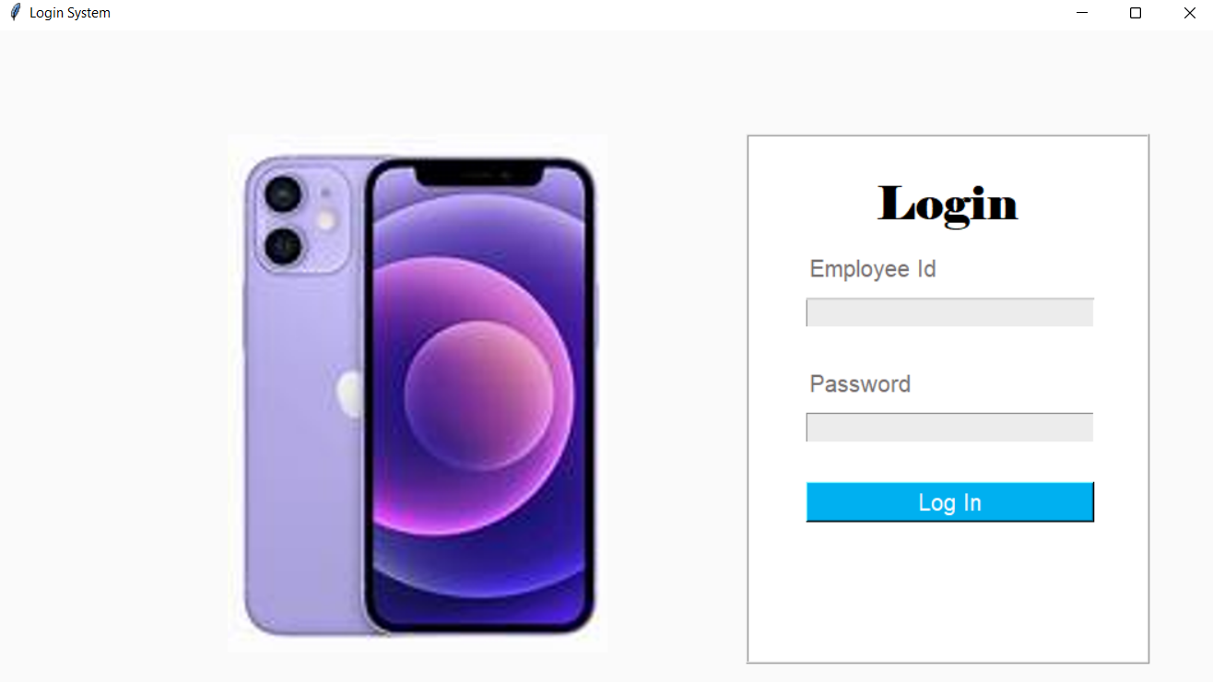

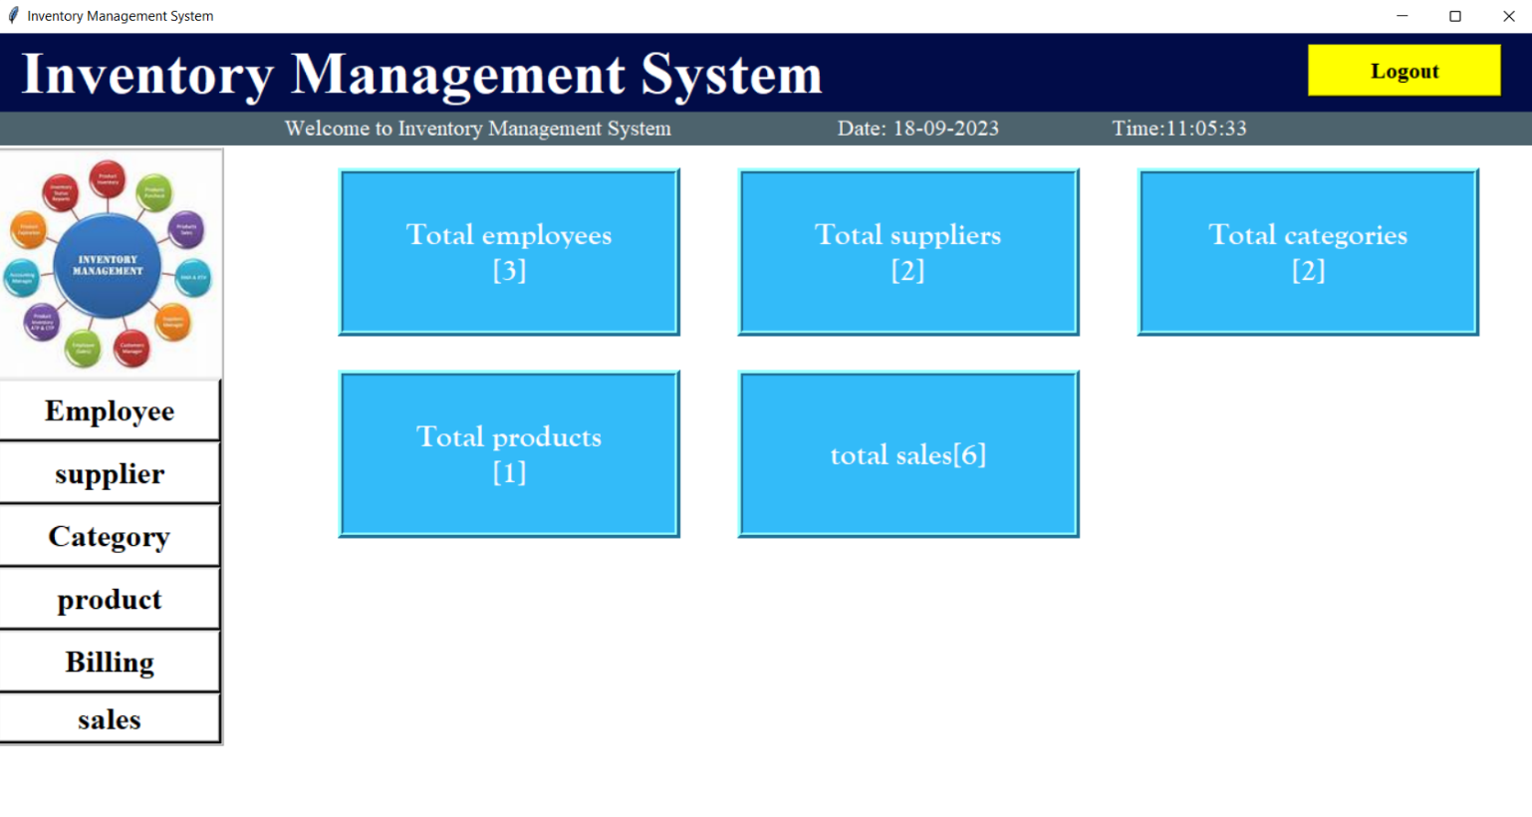

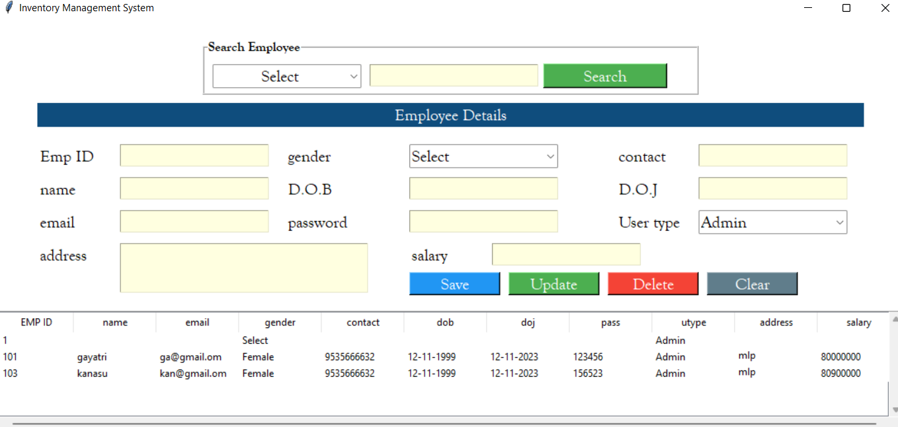

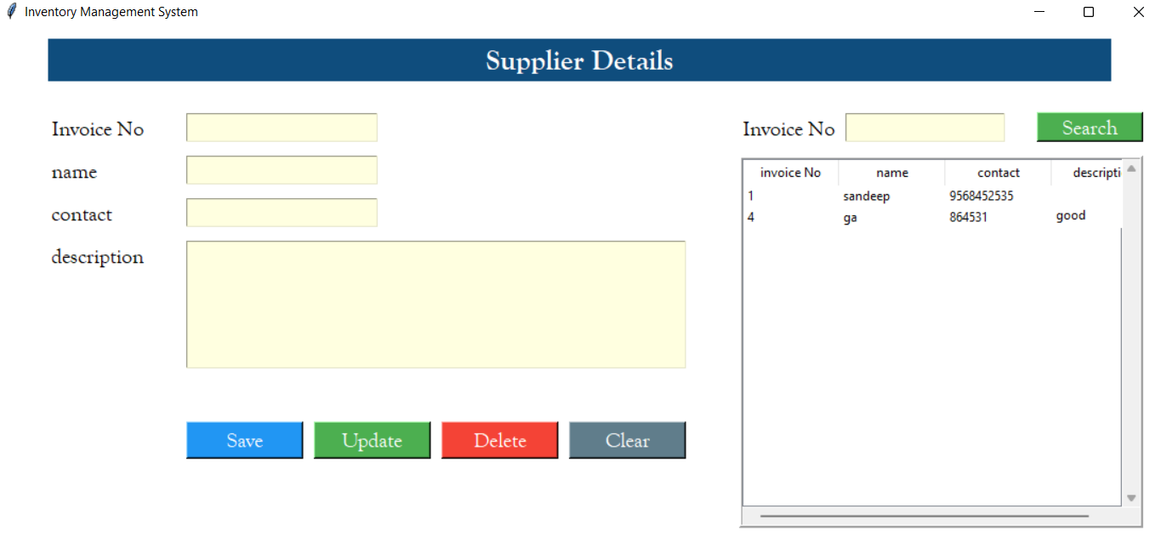

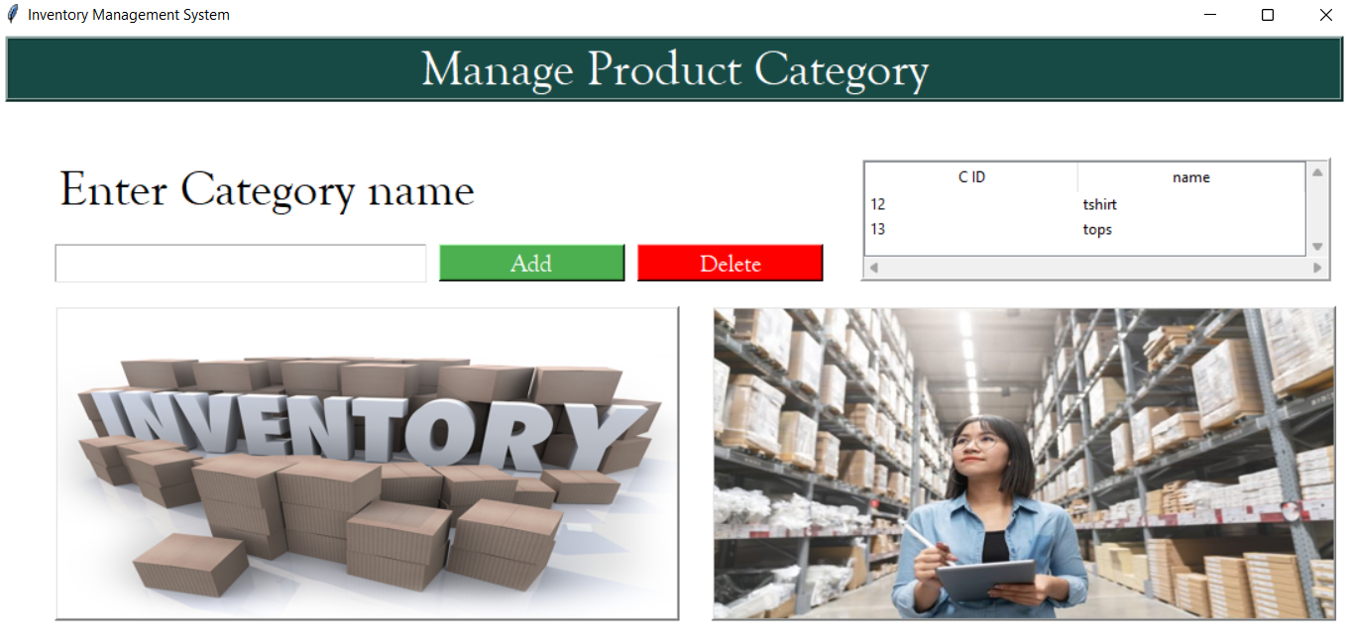

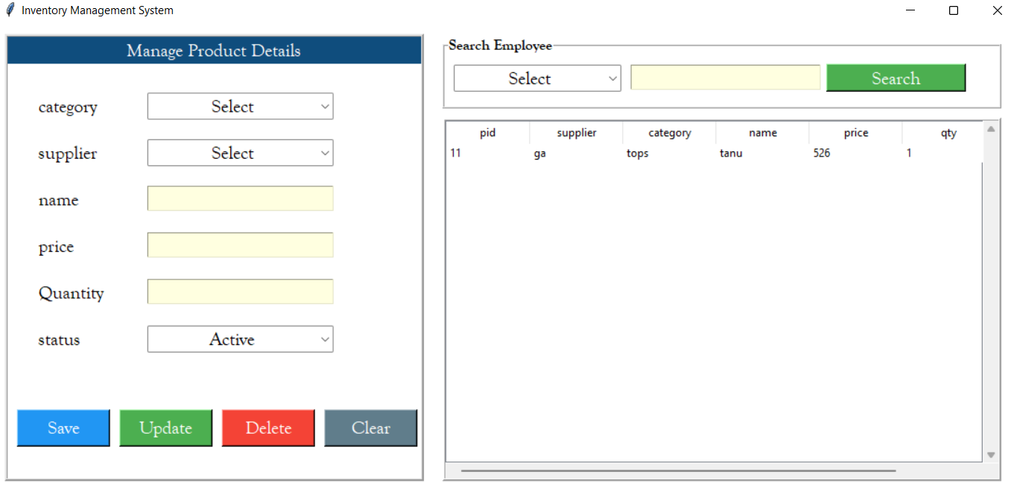

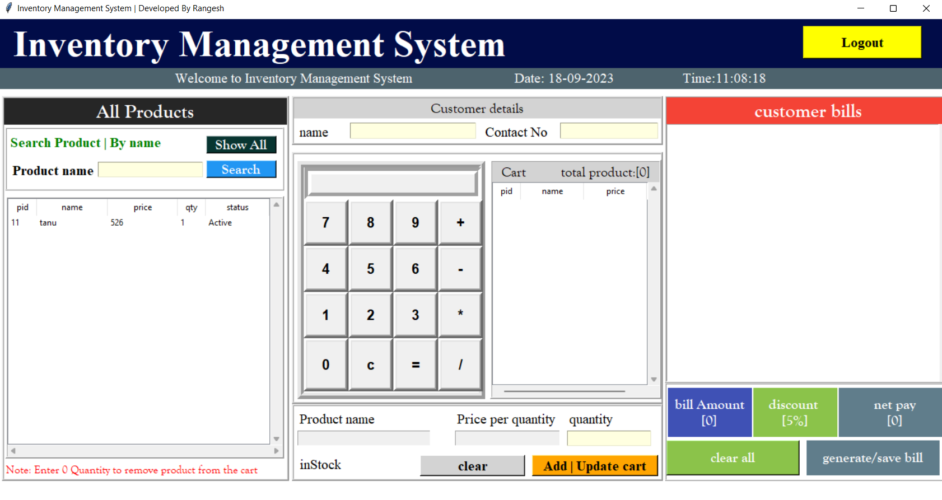

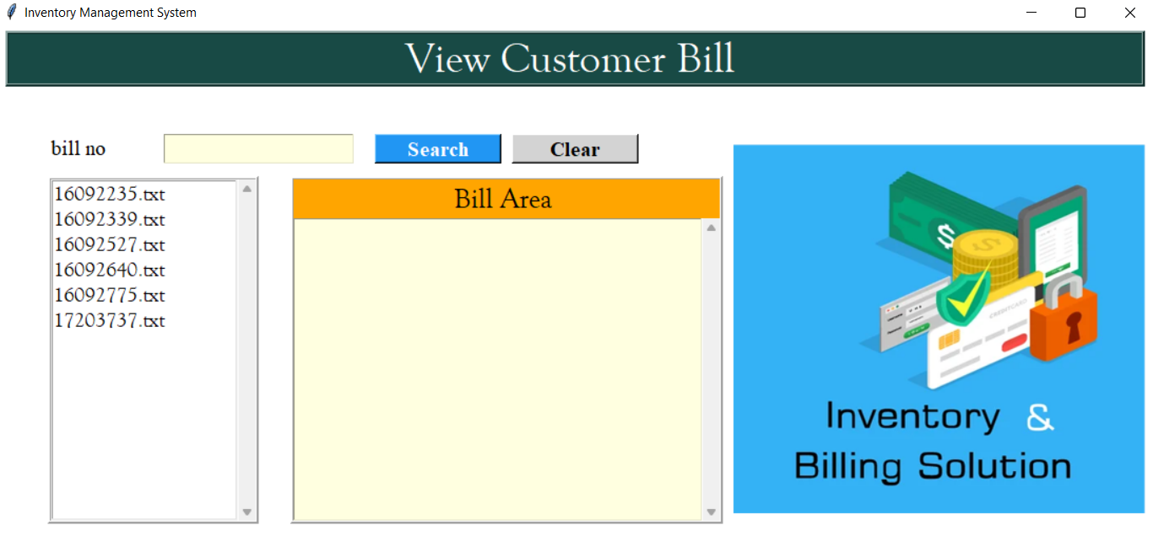

**Conclusion:**

* The development and implementation of the inventory management system have been a significant milestone for our organization. This project undertook the primary goal of optimizing our inventory control processes, improving efficiency, ultimately enhancing our overall business performance.
* The IMS (inventory management system) has successfully improved inventory accuracy by automating data entry, reducing manual errors, and providing real-time tracking of stock levels. This has resulted in
* Reduced stock outs, overstock situations, and associated financial losses.
* The IMS has reduced the time and effort required to track, this has freed up valuable human resources for more strategic tasks.

**Future Enhancement:**

* **AI and Machine Learning:**

Explore the use of AI and machine Learning algorithms for more advanced inventory optimization, including dynamic pricing, demand sensing.

* **Feedback Mechanism:**

Establish feedback mechanisms for users to submit suggestions and report issues, fostering continuous improvement and user engagement.

**References:**

1. Soni,Anita.(2012). Inventory Management of Engineering goods industry in Punjab. International journal of Multidiscriplinary Research.
2. Panigrahi, Ashok K. (2013) Relationship between inventory management and profitability.
3. Srinivas Rao Kasisomayajula (2014) “An analytical Study on Inventory Management”, International journal of Engineering Research
4. Ajaro Tony Martins, Cynthina Ejike, Joy Nwokoro, Solomon(2022)”Inventory management Features, Objective, pros and cons .
5. Atnafu, D., & Balda, A. (2018). The impact of inventory management practice on firms’ competitiveness and organizational performance: Empirical evidence from micro and small enterprises in Ethiopia. Cogent Business & Management, 5(1), 1503219.
6. Jose, T., Jayakumar, A., & Sijo, M.T.. (2013). Analysis of Inventory Control Techniques- A Comparative Study. Internation Journal of Scientific and Research Publications, 3(3), 520–530.
7. Mohamad, S. J. A. N. bin S., Suraidi, N. N., Rahman, N. A. A., & Suhaimi, R. D. S. R. (2016). A Study on Relationship between Inventory Management and Company Performance: A Case Study of Textile Chain Store. Journal of Advanced Management Science, 4(4), 299–304.
8. Plinere, D., & Borisov, A. (2015). Case Study on Inventory Management Improvement. Information Technology and Management Science, 18(1), 91–96.
9. Shen, H., Deng, Q., Lao, R., & Wu, S. (2016). A Case Study of Inventory Management in a Manufacturing Company in China. Nang Yan Business Journal, 5(1), 20–40.
10. Sunitha, K.V. (2012). A Study on Inventory Management in Sujana Metal Products Limited. (Master’s Report, Jawaharlal Nehru Technological University, Hyderabad